Community Health Improvement Plan

Serving Boyd and Holt Counties
2016

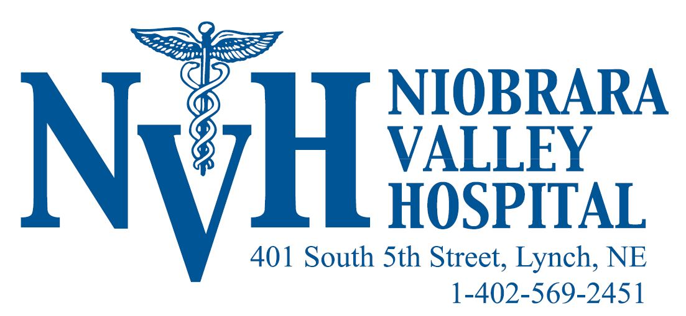
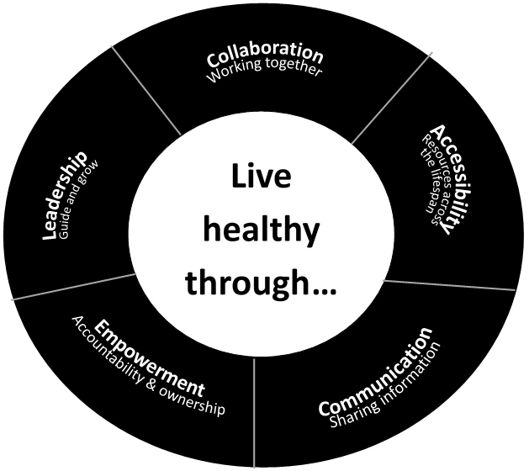
Contents
Acknowledgements 2
Executive Summary 3
Determining Health Priorities 4
Priority 1: Physical Wellness 5
WORK PLAN…………………………………………………………………………………………………………………………………………………………………………….6

Acknowledgements
Niobrara Valley Hospital would like to recognize the following organizations for their participation in the planning sessions that led to the development of this report:

North Central District Health Department (NCDHD)
Antelope Memorial Hospital
Avera Creighton Hospital
Avera St. Anthony’s Hospital
Brown County Hospital
Cherry County Hospital
CHI Health Plainview Hospital
Osmond General Hospital
Rock County Hospital
West Holt Memorial Hospital
The Evergreen Assisted Living Facility
Cottonwood Villa Assisted Living Facility
Good Samaritan Society – Atkinson
Pregnancy Resource Center
Finish Line Chiropractic
Counseling & Enrichment Center / Building Blocks
Region 4 Behavioral Health System
Central Nebraska Community Action Partnership
Northeast Nebraska Community Action Partnership
Northwest Nebraska Community Action Partnership
NorthStar Services
NCDHD Board of Health
North Central Community Care Partnership
Area Substance Abuse Prevention Coalition
O’Neill Chamber of Commerce
Central Nebraska Economic Development
Holt County Economic Development
Knox County Economic Development
Neligh Economic Development
Pierce County Economic Development
University of Nebraska Lincoln Extension Office, Brown-Rock-Keya Paha County
Ewing Public School
Lynch Public School
O’Neill Public School Board
O’Neill Ministerial Association
West Holt Health Ministries
O’Neill Lions Club
O’Neill Rotary Club
Mitchell Equipment – O’Neill, NE
Family Service Child Care Food Program

This report was published in October 2016.

Executive Summary

The Niobrara Valley Hospital Community Health Needs Assessment was conducted to identify primary health issues, current health status & needs and to provide critical information to those in a position to make a positive impact on the health of the region’s residents. The results enable community members to more strategically establish priorities, develop interventions and direct resources to improve the health of people living in the community.
To assist with the CHNA, Niobrara Valley Hospital partnered with North Central District Health Department who retained the services of Dr. Joseph Nitzke for data collection, compilation, analysis, and presentation. The results enable the hospital, local health department and other providers to more strategically establish priorities, develop interventions and commit resources.
Through the process of completing the Community Health Needs Assessment, as well as assessing the resources available to this organization and surrounding communities, it was determined that the most significant need to be addressed by Niobrara Valley Hospital is the Physical Wellness of the communities, primarily in the areas of diabetes and blood pressure. By addressing these two health issues, Niobrara Valley Hospital has the opportunity to vastly decrease the death rate attributed to heart disease.
Other needs identified by the CHNA that are not part of Niobrara Valley Hospital implementation strategy, 1.) Aging Population & Related Issues, 2.) Mental Wellness and 3.) Substance Abuse are being addressed by existing community assets shown through the local health department plan because the necessary resources to meet these needs are lacking, or these needs fall outside of the Niobrara Valley Hospital areas of expertise.

DETERMINING Health Priorities

How did we get here?

The Community Health Assessment and Community Health Improvement Plan were developed through a community-driven strategic planning process called Mobilizing for Action through Planning and Partnership (MAPP). The MAPP process commenced in July of 2015 and took approximately 15 months to complete. North Central District Health Department (NCDHD) guided the processes and incorporated members and representatives of many organizations throughout the health district.
The Community Health Assessment was completed by obtaining and reviewing health data for the community. The Community Health Improvement Plan details strategic issues noted throughout the assessment process and outlines goals and strategies to address identified health priority areas.
Data related to the health of the North Central District referenced throughout this document can be found on the NCDHD website: www.ncdhd.gov

PURPOSE
We recognize that by including members from many organizations throughout the community, we can accomplish more than what could be done by any one organization alone. The purpose of the Community Health Improvement Plan is not to create a heavier workload for our partners, but rather, to align efforts of these various organizations to move forward in improving the health of the community in a strategic manner. Community partnership also serves to create a broader representation of community perspectives and engender ownership of the efforts aimed at addressing identified priority health issues.
What follows is the result of the community’s collaborated effort and planning to address health concerns in a way that combines resources and energy to make a measurable impact on the health issues of the North Central District community. We understand there are many assets within the North Central District that will aid in the accomplishment of these goals.
PROCESS
Results of the community health assessment were presented to planning partners at the community prioritization meeting. Significant health issues were highlighted and evaluated for priority status. Each priority of concern was written on a sheet of paper and put on the wall for stakeholders to vote on. During this prioritization process, the group created categories from issues based on themes and relationships between issues. The process resulted in several theme areas: aging issues, environmental health, mental health, substance abuse, chronic diseases, and others. Stakeholders then voted on the issues they felt were most important.
Following the community prioritization process, stakeholders were divided into groups to identify goals, strategies, and resources that can be put forth to address the issue at hand. During this meeting, each group was tasked with a specific health priority to address. These groups met several times to discuss objectives, strategies, activities, and organizations that can be utilized to meet specific goals.
Work groups for each priority health issue will meet regularly to implement action plans and ensure progress is being made to obtain goals. NCDHD will assist in convening these meetings and measuring progress with each work plan.
Priority 1: Physical Wellness

STRATEGIC ISSUE 1: HOW DO WE OPTIMIZE PHYSICAL WELLNESS WITHIN THE HEALTH DISTRICT?
CURRENT SITUATION

Diabetes by itself is now regarded as the strongest risk factor for Heart Disease; however, a variety of mechanisms—not solely blood glucose levels—most likely come into play. The blood vessels in patients with diabetes are more susceptible to other well-established risk factors. According to the ADA, the combination of High Blood Pressure and Type 2 Diabetes is particularly lethal and can significantly raise a person’s risk of having a heart attack. The age-adjusted death rate of Heart Disease in Boyd County is at 209.5 per 100,000 compared to 149.8 per 100,000 for the state of Nebraska and the age-adjusted death rate for Ischemic Heart Disease in Boyd County at 135.7 per 100,000 compared to the Health People 2020 goal of less than 103.4 per 100,000. Niobrara Valley Hospital saw this as a great opportunity to implement a tracking system to monitor and establish measures in the areas of diabetes and high blood pressure to help decrease the deaths associated with heart disease.

The remaining pages in this document outline the work plan that Niobrara Valley Hospital (NVH) will use to address the priority health issue of physical wellness. Over the course of the next three years, NVH will commit resources and efforts to activities as outlined in the work plan. This section is meant to be a flexible, responsive component of the community health improvement plan. As such, it will periodically be reviewed and updated to ensure the elements reflect our progress and the needs of our community.

Priority 1: Physical Wellness

Goal: IMPROVE COMMUNITY PHYSICAL HEALTH AND WELLNESS.

OBJECTIVE 1.1: | Increase the proportion of adults who have had their blood pressure measured.
EVIDENCE-BASED STRATEGIES:
NVH will conduct blood pressure screenings at health fairs and events sponsored by the hospital & Medical Clinic.
Attempt telephone follow-up with 100% of those who have a stage 2 hypertension result who do not opt out of follow-up and have a working telephone.
Provide educational brochures to those who have been identified about the importance of medication adherence and healthy lifestyle.

OUTCOME INDICATORS
SHORT AND INTERMEDIATE TERM
Number of communications in existing hospital communications vehicles that highlight hypertension and how it can be prevented/treated successfully.
Percent of eligible individuals with whom successful contact was made.
LONG TERM
Increase the proportion of adults who have had their blood pressure measured and can state whether their blood pressure was normal or high.

OBJECTIVE 1.2: | Increase the number of people getting screened for diabetes.
EVIDENCE-BASED STRATEGIES:
At community screening events, offer a hemoglobin A1C following approved guidelines to find possible diabetes.
A telephonic follow-up attempt will be made to 100% of those whose hemoglobin A1C falls out of recommended ranges.

OUTCOME INDICATORS
SHORT AND INTERMEDIATE TERM
Number of people getting screened for diabetes.
Number of people receiving a hemoglobin A1C following approved guidelines to find possible prediabetes.
LONG TERM
Increase the number of those who are diagnosed with diabetes but do not know they have this disease.

